## Project description

Use the network protocol analyzer (Wireshark) to filter data to:

Identify the source and destination IP addresses involved in this web browsing session, examine protocols that are used when a user makes the connection to the website, and analyze some of the data packets to identify the type of information sent and received by the systems that connect to each other when the network data is captured.

## Task 1. Explore data with Wireshark.

Here, I opened the packet captured file named sample with a network protocol analyzer software called **Wireshark.** The file contains the captured data from a system that made web requests to a site. The packet capture file has a .pcap file extension that is hidden by default by Windows Explorer and on the desktop view.

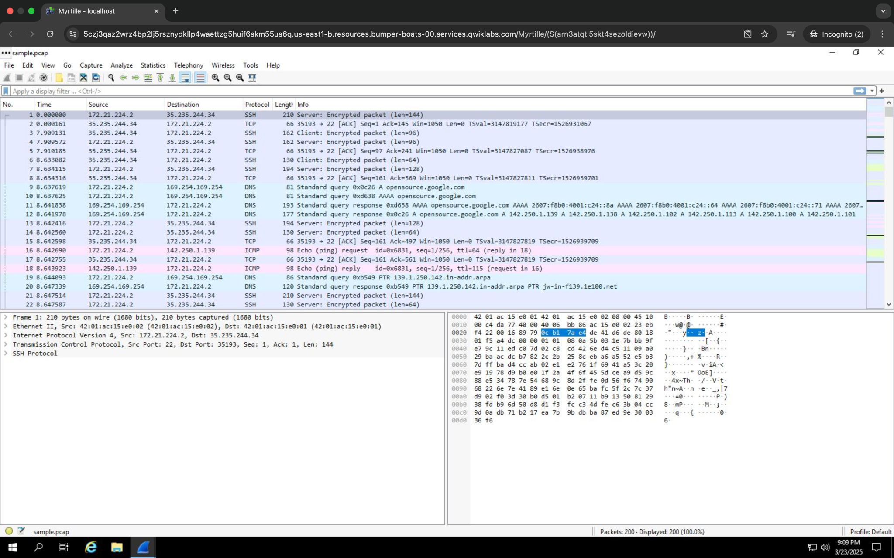

Task 2. Apply a basic Wireshark filter and inspect a data packet.

For this task, I successfully analyzed a network packet using Wireshark to examine its details across various network layers and protocols. I applied a display filter to isolate the traffic associated with a specific IP address, using the following filter in the "Apply a display filter" text box above the packet list:

ip.addr == 142.250.1.139

This enabled me to focus solely on the traffic related to the specified IP address, allowing for a more detailed inspection of the relevant network activity.

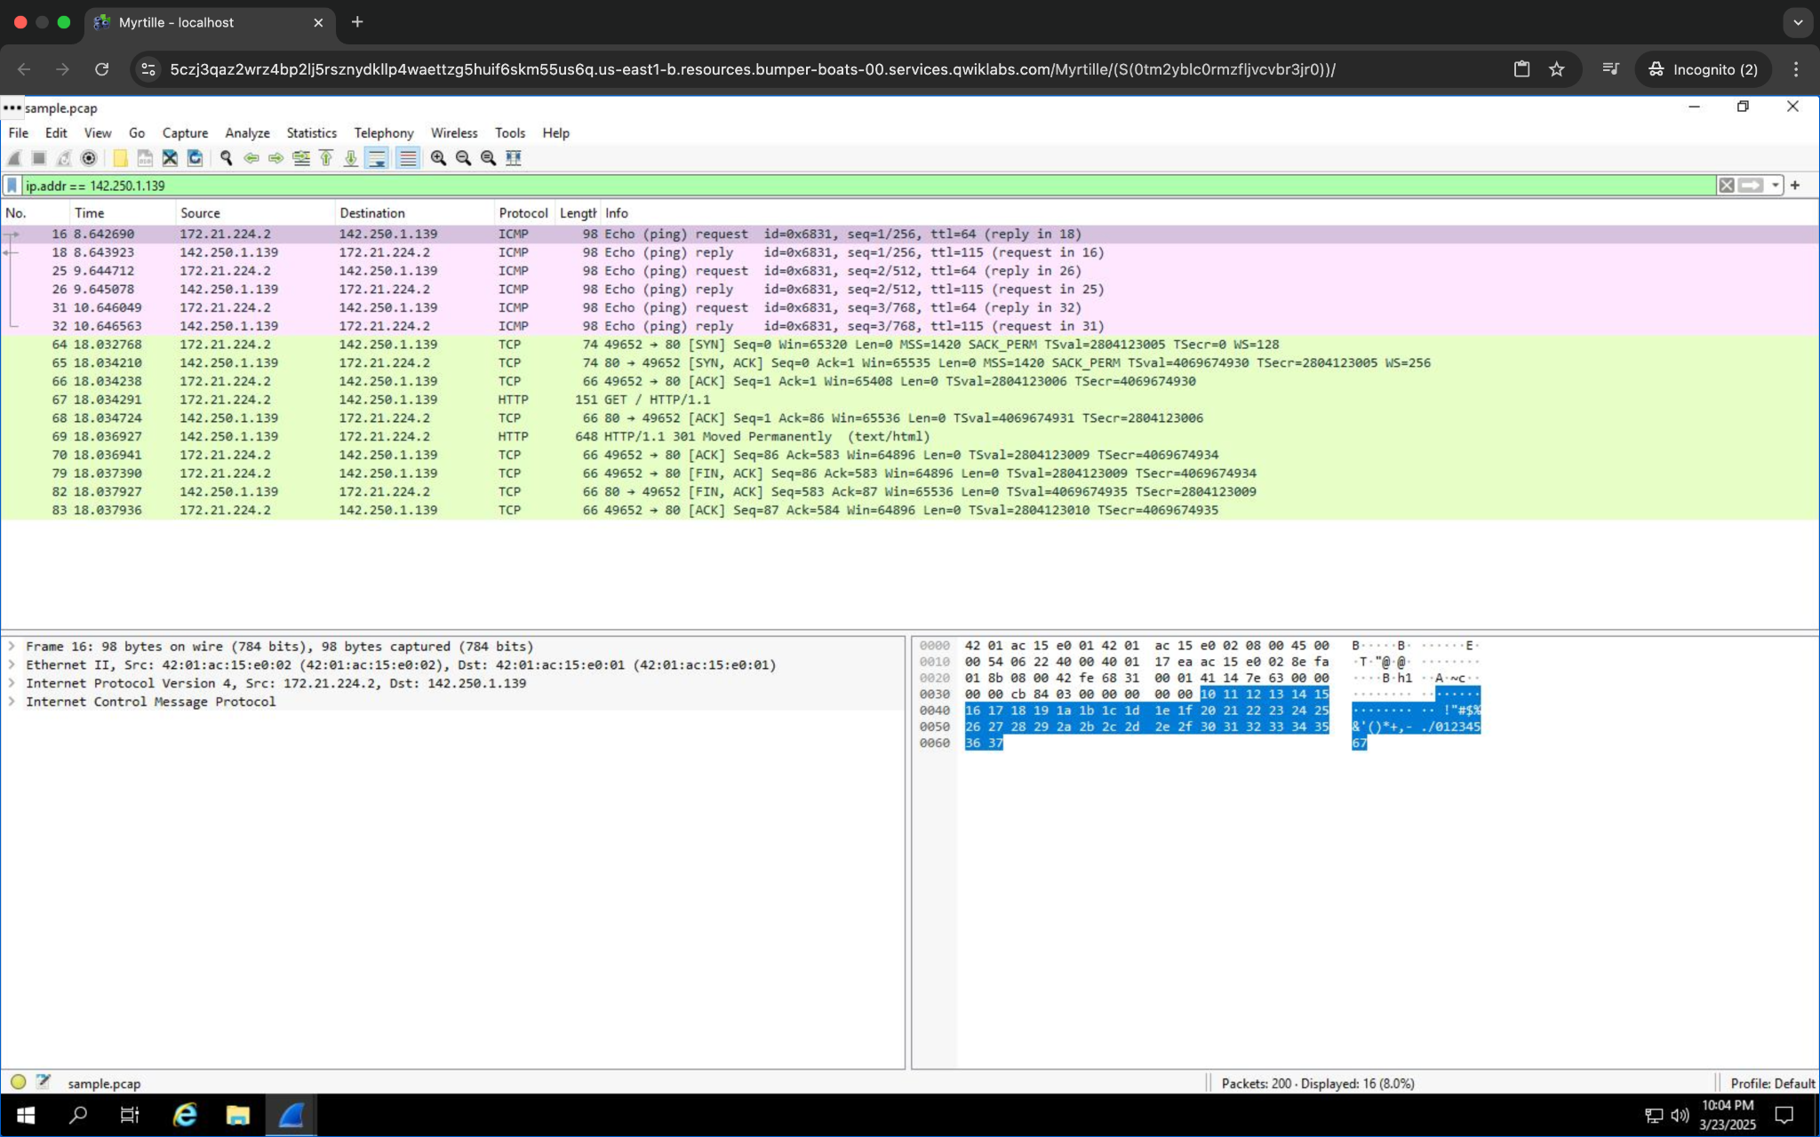

The list of packets displayed is now significantly reduced and contains only packets where either the source or the destination IP address matches the address I entered. Now only two packet colors are used: **light pink** for ICMP protocol packets and **light green** for TCP (and HTTP, which is a subset of TCP) packets.

Task 2b. Inspect the first tcp packet.

I examined the first TCP packet in the filtered list, delving into various network layers, including Ethernet, IP, and TCP headers.

I double-clicked the first packet that listed TCP as the protocol. This opened a packet details pane window:

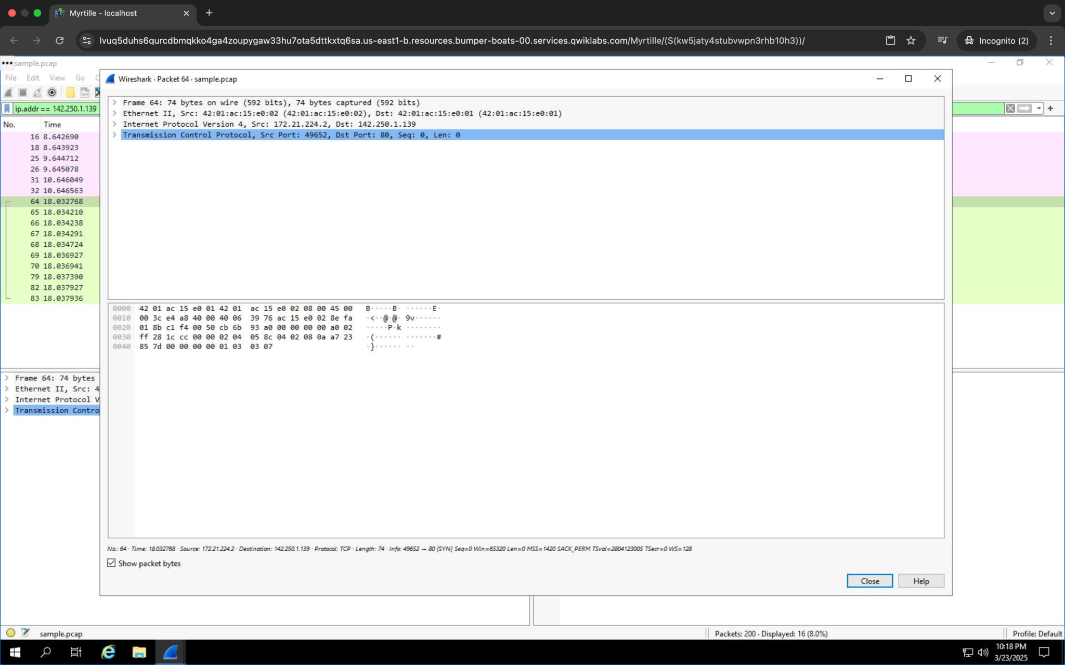

The upper section of this window contains subtrees where Wireshark will provide you with an analysis of the various parts of the network packet. The lower section of the window contains the raw packet data displayed in hexadecimal and ASCII text.

## Task 3. Use filters to select packets

I used filters to refine my analysis further. By applying ip.src == 142.250.1.139, I isolated packets originating from this specific IP. Similarly, I used ip.dst == 142.250.1.139 to filter for traffic destined to the same address. I also explored Ethernet MAC address-based filtering with eth.addr == 42:01:ac:15:e0:02 to focus on packets associated with a particular MAC address.

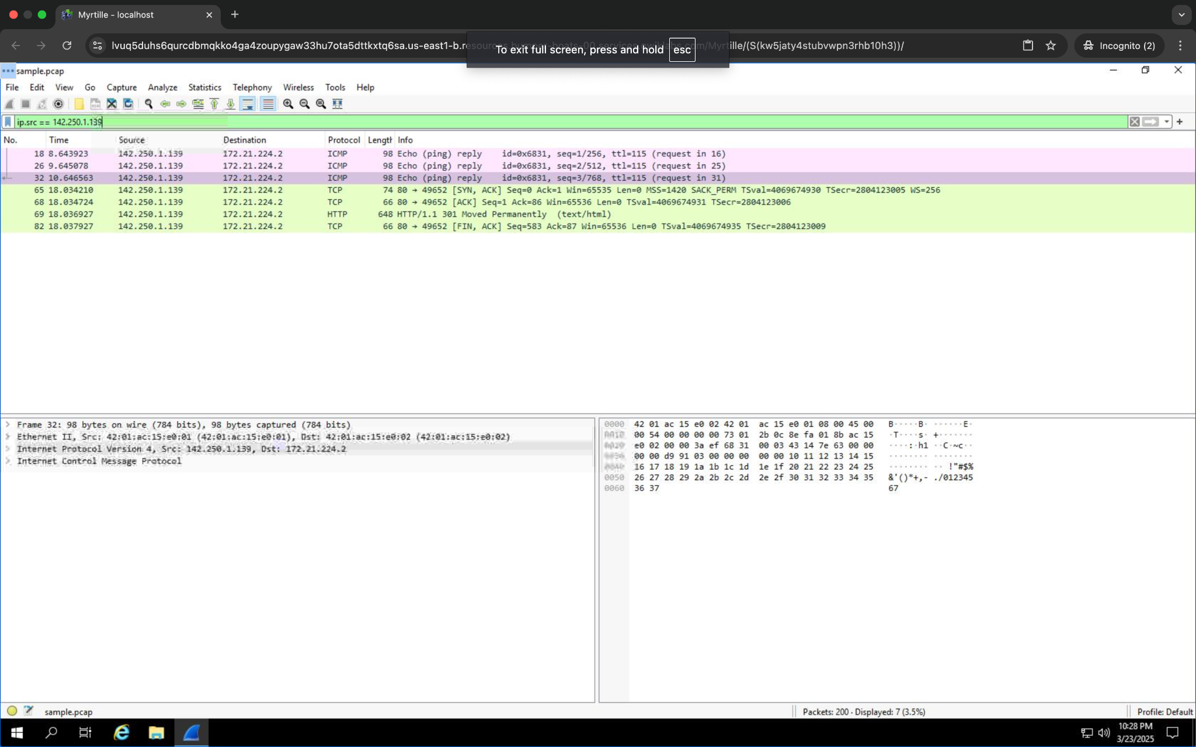

## 

## Task 4. Use filters to explore DNS packets

I used the udp.port == 53 filter to examine DNS traffic. I investigated DNS query and response packets, identifying DNS queries and analyzing the responses to obtain resolved IP addresses, including 142.250.1.139 for the domain opensource.google.com.

## 

## Task 5. Use filters to explore TCP packets

For web traffic analysis, I used the filter tcp.port == 80 to focus on HTTP packets, examining properties such as Time to Live (TTL), Frame Length, and Header Length. I also filtered packets containing specific payload text with tcp contains "curl" to investigate web requests initiated by the curl command.

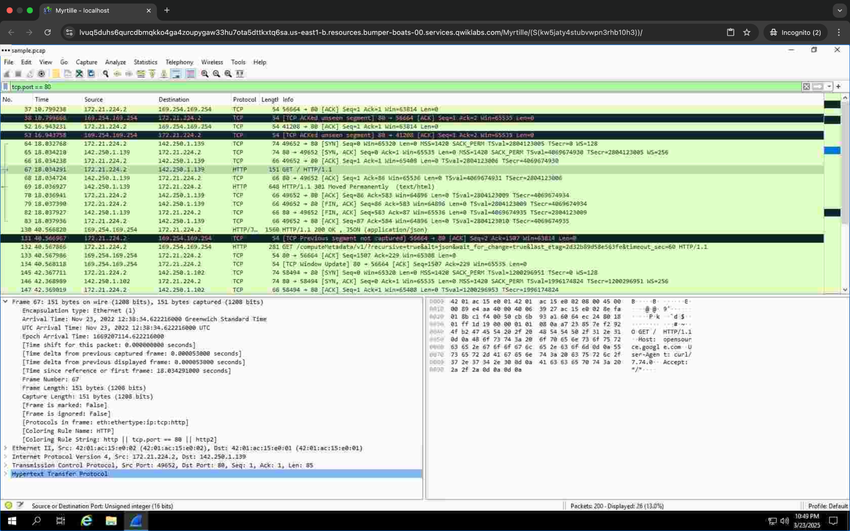

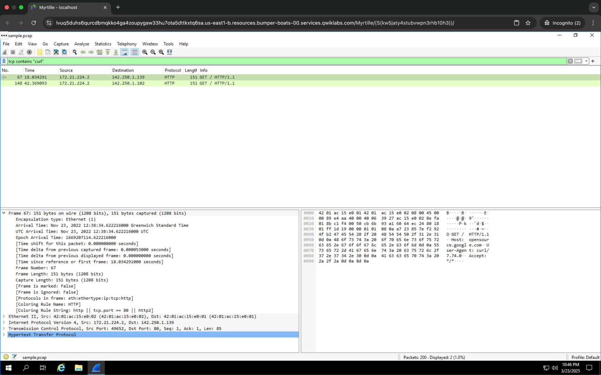

## Summary

This comprehensive packet inspection, coupled with the strategic use of filters, allowed me to isolate and analyze specific network traffic, enhancing my understanding of network communications relevant to security analysis.